[1]

A Reactive Online Optimization Based Whole Body Control for Quadruped Locomotion over Challenging Terrain

Seung woo Hong and JongHun Choe

*Abstract*— In this study, a reliable control framework for a quadruped robot that combines compliance, robustness, reactiveness, and versatility is proposed. The control framework consists of two levels of controller, the high-level determines the robust and reactive footstep trajectory of the robot, and the low-level provides optimized solution for best tracking those trajectories using optimization based full body inverse dynamics. The proposed controller is capable of walking across challenging terrains, recovering balance with sharp push, and implementing various dynamic gaits. The performance of the proposed controller is verified via a full body simulator.

# INTRODUCTION

In the field of Civil Engineering, robots are being come up with as alternatives in restricted or hazardous environments. Especially in dangerous environments such as disaster relief situation, the need for robots is increasing. UAV, wheeled robots, and legged robots have been proposed to replace the workforce.

In the disaster environment, robots should make lots of interactions with its surroundings like activate valves, pull the lever, and go up and down the uneven platform. Wheeled robots, which have been widely used in the field, have limited performance to uneven terrain, large gaps, and obstacles made of debris, and so on due to their physical configuration. While UAVs can overcome some of these problem, they are easily affected by the climate like heavy fog and windy weather, and their payload capacity and energy autonomy can be limiting. Legged robots are better solution in the challenging environment mentioned above. Furthermore, since they can interact surroundings directly through anthropomorphous manipulators, they have a potential to perform versatile tasks.

Compliance is the essential ability for robot in order to interact safely with complex environments. The robots controlled by a traditional ‘joint position control method’ generally uses a high gain to maintain the endpoint position accuracy, thus their joints has high stiffness. To maintain robot compliance without sacrificing position accuracy, inverse dynamic control method is widely used.

Nowadays, researches have been conducted to control legged robot through inverse dynamics control method. Various studies have extended the ‘operational space control framework’ proposed by [1] and applied to floating based system, through Quadratic Programming (QP) method. In other words, using the convex optimization to calculate the reference control that finest follows the desired motion which given in the task space, while satisfying various constraints. [2] and [3], using hierarchical method, projected secondary tasks to null space of the high-priority tasks, thus implemented secondary tasks without interfering with the high-priority desired motions. However, there were disadvantages in that it is hard to implement desired motions with same priority, and in specific situation, there is no feasible solution. In contrast to the hierarchical method that formulates the cost functions as hard constraints, [4] used soft constraints by adding corresponding terms with weight in the cost function.

Unlike the fixed base system, a contact force term exists in the equation of motion of the float base system, thus its sensing is needed. However, due to the characteristics of the force/torque sensor, the sensor noise is severe, if the low pass filter is used, the overall control bandwidth is decreased because of the phase delay. To compromised this issue, [5], [6] and [7] solved the QP problem using optimization states consisting of joint accelerations and joint torque except contact force by mapping the equation of motion to a support-consistent manifold. However, using the reduced optimization states has an issue that it is hard to handle the contact force constraint explicitly. Therefore, [8], [9] and [4] considered to use full optimization states, which consisting of joint acceleration, joint torque and contact force. Although using the full optimization states can affect the computation time due to high dimensionality of QP, according to [4], it is still solvable in real time (3ms).

A method for generating a desired motion of a floating base system has also been intently studied. Zero Moment Point (ZMP) [10], [11] based method generates reference CoM trajectory of robot through reference foot positions. However, ZMP based method generates the CoM trajectory from the predetermined foot positions, thus that the robot movement is highly restricted and its robustness against unexpected disturbance is degraded.

The method based on Capture Point (CP) [12], [13] is to calculate the approximation of foot positions that can eventually stop the robot. It requires only the information about the CoM position and velocity of the robot. Moving speed of the robot could be adjusted by stepping CP with an offset. In contrast to the ZMP method, this method generates the reference foot positions that can maintain the stability by using feedback of the current CoM information. Thus, it is robust to external disturbance.

In this study, we propose a control framework, which has the following characteristics: highly compliant (safe interaction with environment), reactive to disturbance, and energy efficient. The framework integrates the work of previous researches in the humanoid field that gives the floating base legged robot abilities to work in a challenging environment. High-level controller performs drift compensation that formulates still movement with zero desired CoM velocity as an input based on CP approach. In the low-level controller, we formulate the floating base inverse dynamics as a QP problem, and we directly optimize a quadratic cost in terms of optimization states consists of joint accelerations, joint torques, and contact forces.

# High-Level Controller (HLC)

## Linear Inverted Pendulum Model (LIPM)

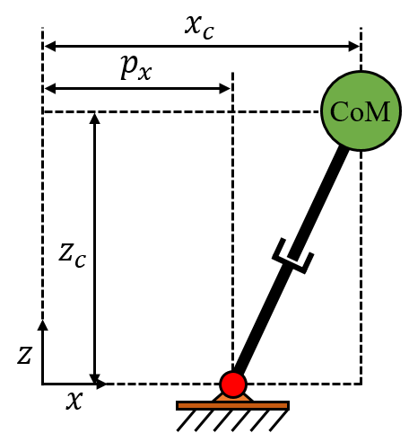

Figure 1. Linear Inverted Pendulum Model

$$\begin{aligned}{\ddot{x}}_{c}=ω^{2}\left(x_{c}-p_{x}\right)\#\left( SEQ Equation \backslash * ARABIC 1\right)\end{aligned}$$

The linear inverted pendulum model (LIPM) is one of widely used simplified model in legged robot era [11]. The CoM dynamics with LIPM has several benefits. First, its dynamics equation is linear. Second, on horizontal directions ( $x,y$ in Figure 1.), it has equivalent, and independent equations. The dynamics equation about x-direction is easily able to apply on y-direction. Furthermore, LIPM has following assumptions:

* All mass of the robot are concentrated at CoM
* The z-direction height of the robot CoM is constant
* There is no torque apply where the pendulum contacts with the ground.

The point which pendulum touches the ground is called ‘Zero Moment Point’ (ZMP) [10]. The CoM dynamics can be controlled by changing ZMP position as an input.

$$\begin{aligned}x\left(t\right)=\left[{\cosh\left(ωt\right) \atop ω\sinh\left(ωt\right)}{\frac{1}{ω}\sinh\left(ωt\right) \atop \cosh\left(ωt\right)}\right]x_{0}+\left[{1-\cosh\left(ωt\right) \atop -ω\sinh\left(ωt\right)}\right]p_{x}\#\left( SEQ Equation \backslash * ARABIC 2\right)\end{aligned}$$

Equation (2) is representation of x-direction state of CoM. In (2), $ω=\sqrt{g/z_{c}} (assume positive)$, $x_{0}$ is initial state, and $p_{x}$ is the position of ZMP.

## Capture Point (CP)

The point where on the ground that makes the robot model completely still is called the ‘Capture Point’ [12], [13]. And the capture point is easily calculated from current CoM state.

$$\begin{aligned}ξ=x_{c}+\frac{{\dot{x}}_{c}}{ω}\#\left( SEQ Equation \backslash * ARABIC 3\right)\end{aligned}$$

Equation (3) shows the the capture point about the CoM condition. CoM is able to be controlled by adjusting the offset distance between the ZMP and the capture point. If the ZMP of the model exactly step the capture point, the CoM will just stop above of the capture point. However, if the robot steps the capture point with some offset, then the CoM will accelerate positive or negative direction.(it belongs to sign of the offset.)

## Foot placement control to prevent CoM drift

In quadruped robot, an equation of foot placement of the robot can be represented like below, (4). It is a sum of feedback term of LIPM dynamics and feedforward term of desired CoM velocity [14].

$$\begin{aligned}p_{x}=\underset{Feedback}{\underbrace{\frac{1}{ω}\left({\dot{x}}_{c}-{\dot{x}}_{desired}\right)}}+\underset{Feedforward}{\underbrace{\frac{1}{2}T_{step}{\dot{x}}_{desired}}}+{x_{c}+p}_{CoM,hip}\#\left( SEQ Equation \backslash * ARABIC 4\right)\end{aligned}$$

In (4), $T_{step}$ is desired step time, and $p_{CoM,hip}$ is a displacement from CoM to the starting point of the robot`s leg.

It is obvious to find the foot placement of the quadruped robot with (4). However, in real situation, it is complicated to induce precise CoM location. Thus, the drift occurs despite the operator gives standstill command (${\dot{x}}_{desired}=0$) to the robot. Therefore, we are trying to compensate these drift effects with applying drift-compensation loop to (4).

Let ${\dot{x}}_{desired,0}$ is original desired CoM velocity, then during specific step time $T_{step},$ desired CoM displacement is following,

$$\begin{aligned}x_{desired}={\dot{x}}_{desired,0}T_{step}\#\left( SEQ Equation \backslash * ARABIC 5\right)\end{aligned}$$

With (5), we can construct the feedback loop about desired CoM velocity.

$$\begin{aligned}offset=k_{p}\left(x_{desired}-x\right)\#\left( SEQ Equation \backslash * ARABIC 6\right)\end{aligned}$$

$$\begin{aligned}{\dot{x}}_{desired}={\dot{x}}_{desired,0}+offset\#\left( SEQ Equation \backslash * ARABIC 7\right)\end{aligned}$$

Therefore, applying (7) to (4), there is a compensation about the CoM drifting.

# Low-Level Controller

The goal of low-level control is to solve for a set of optimized torque commands that track the desired motions given by the high-level controller as closely as possible. By formulating floating base full body inverse dynamics problem as a Quadratic Programming (QP) problem, the low-level controller generates a set of optimized torque commands via a standard QP solver at every time step of the control loop

## QP formulation

A set of desired motions given by the high-level controller can be represented as a set of linear equations

$$\begin{aligned}A_{i}x=b_{i}\#\left(8\right)\end{aligned}$$

where $x$ is optimization variable, $i=1, …, n$ is the number of the desired motion. As mentioned earlier, the goal of the low-level controller is to find a set of joint torques that tracks the given desired motion trajectory as closely as possible in a least squares sense

$$\begin{aligned}\min_{x}{ }{\left\|A_{i}x-b_{i}\right\|}_{2}^{2}\#\left(9\right)\end{aligned}$$

Given a set of desired motions with relative priority, (9) can be stacked into a large linear least squares form as

$$\begin{aligned}\min_{x}{ }{\left\| \underset{A}{\underbrace{\left[\begin{aligned}&{w_{1}A}_{1} \\ &w_{2}A_{2} \\ ⋮ \\ {w_{n}A}_{n}\end{aligned}\right]}}x-\underset{b}{\underbrace{\left[\begin{aligned}&{w_{1}b}_{1} \\ &w_{2}b_{2} \\ ⋮ \\ w_{n}b_{n}\end{aligned}\right] }}\right\|}_{2}^{2}\#\left(10\right)\end{aligned}$$

where $w_{i}$ is the weight that emphasizes the relative priority among desired motions. To achieve the given desired motions for a floating base quadruped robot, it is required to integrate equality and inequality constraints such as dynamic or kinematic constraints. For this reason, the constrained linear least squares problem can be formulated as QP formulation

$$\min_{x}{ } \frac{1}{2}x^{T}Qx+c^{T}x$$

$$s. t. A_{E}x=b_{E}$$

$$\begin{aligned}A_{I}x≤b_{I}\#\left(11\right)\end{aligned}$$

where $Q=2∙A^{T}A$, $c=-2∙A^{T}b$, and $A_{E}$, $b_{E}$, $A_{I}$, $b_{I}$ are equality and inequality constraints, respectively. The details of how we choose optimization variables, objective functions, equality constraints, and inequality constraints respectively will be introduced in the following sections.

## Floating based inverse dynamics

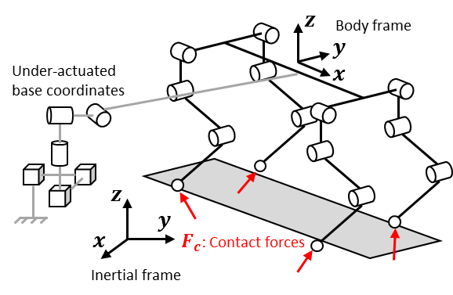

Figure 2. The floating base attached to the quadruped robot is represented to the inertial frame through 6 DOFs virtual joints.

The equations of motion (EoM) for a floating base quadruped robot can be expressed as

$$\begin{aligned}M\left(q\right)\ddot{q}=S^{T}τ-h\left(q,\dot{q}\right)+J_{c}{\left(q\right)}^{T}F_{c}\#\left(12\right)\end{aligned}$$

where $q=[{q_{u}}^{T} {q_{a}}^{T}]∈R^{18×1}$ is the generalized coordinates of floating base system, $q_{u}∈R^{6×1}$ is the position and Euler orientation of the under-actuated coordinates attached to the floating base as shown in figure 1, $q_{a}∈R^{12×1}$ is the actuated joint coordinates, $M\left(q\right)∈R^{18×18}$ is the inertia matrix, $h\left(q,\dot{q}\right)$ is the sum of the floating base Coriolis, centripetal and gravitational forces, $S=[0_{12×6} I_{12×12}]∈R^{12×18}$ is a selection matrix that separates the actuated joint coordinates $q_{a}$ from the under-actuated floating base coordinates $q_{u}$, $τ∈R^{12×1}$ is the actuated joint torques, $J_{c}\left(q\right)={∂x_{c}}/{∂q}∈R^{3n_{c}×18}$ is the contact Jacobian matrix that maps the ground reaction forces $F_{c}∈R^{3n_{c}×1}$ at foot contact point positions $x_{c}∈R^{3n_{c}×1}$ in Cartesian space, $n_{c}$ is a scalar value that represents the number of contact foots on the ground.

Since the states $q$, $\dot{q}$ of the robot can be obtained through the encoders arranged at the respective actuated joints, the EoM are linear in terms of the generalized accelerations $\ddot{q}$, actuated joint torques $τ$, and contact forces $F_{c}$. For this reason, we choose QP optimization variables as

$$\begin{aligned}x=\left[\begin{matrix}\ddot{q} \\ τ \\ F_{c}\end{matrix}\right]\#\left(13\right)\end{aligned}$$

In addition to the EoM that describes the torques or forces required to achieve the desired motion, the kinematic constraints should also be considered and it can be expressed as

$$\dot{x}=J_{c}(q)\dot{q}$$

$$\begin{aligned}\ddot{x}=J_{c}\left(q\right)\ddot{q}+{\dot{J}}_{c}\left(q,\dot{q}\right)\dot{q}\#\left(14\right)\end{aligned}$$

where $\dot{x}$, $\ddot{x}$ are the actuated joint velocities and accelerations expressed in Cartesian Space.

In the following section, the details of formulating desired motions, EoM constraint and kinematic constraints as QP criterion will be introduced.

## Floating base inverse dynamics as QP criterion

1) Objective functions:

Generally, a set of desired motions such as foot and CoM motions given by the high-level controller are expressed in Cartesian space. We can formulate the desired motions using (14) into the form of (8) as

$$A_{cart}=\left[\begin{matrix}J(q) & 0 & 0\end{matrix}\right]$$

$$\begin{aligned}b_{cart}={\ddot{x}}_{des}-\dot{J}\left(q,\dot{q}\right)\dot{q}\#\left(15\right)\end{aligned}$$

where ${\ddot{x}}_{des}$ are the set of desired motions from high-level controller. Note that for the foot contact points accelerations ${{\ddot{x}}_{c}}_{des}$ should be set to zero to avoid slipping hazard occurred.

2) Equality constraint:

Since all the given desired motions are tightly related to the EoM, it is formulated as equality constraint in (11) as

3) Inequality constraint:

To minimize the slipping hazard of contact foots, we enforce the friction constraints as

$$\left|{F_{c}}_{x}\right|≤μ{F_{c}}_{z}$$

$$\begin{aligned}\left|{F_{c}}_{y}\right|≤μ{F_{c}}_{z}\#\left(17\right)\end{aligned}$$

where ${F_{c}}_{x},{F_{c}}_{y},{F_{c}}_{z}$ are the $x, y, z$ components of the ground reaction forces $F_{c}$ at foot contact point positions.

# Result

## Drift-compensation on high-level controller

To find out the effect of drift-compensation feedback loop, (7) that applied to the foot placement equation (4), we performed simulation with ‘Choreonoid’ simulator. All the sensors had a white noise as an error. The desired CoM velocity was ${\dot{x}}_{desired}=0$, and simulation time duration was 50 seconds.

Effectiveness of the compensation feedback is showed on figure 3. and figure 4.. Without the compensation feedback, the drift occurred. Figure 3. shows that the robot CoM diverges as time goes on. ~~The x-direction CoM location constantly flowed, and y-direction also.~~ On the other hand, with compensation, the feedback gain was $k_{p}=1$. As the result above figure 4., the CoM position error ~~converged~~ merged to specific point, error of the CoMx converged to 0.17m, and error of the CoMy converged to 0.15m, approximately.

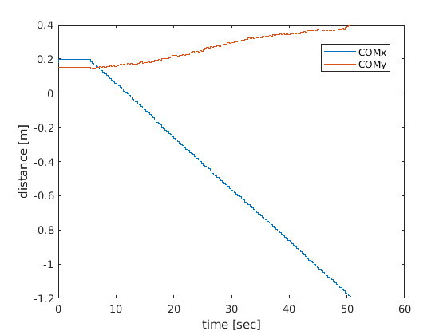

Figure 3. The CoM horizontal postion with no drift compensation

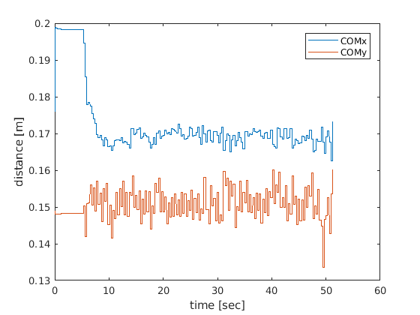

Figure 4. The CoM horizontal postion with drift compensation

## The robustness of low-level controller

The quadruped robot was able to perform forward walk, lateral walk, and turning walk stably without drift in simulation. Furthermore, to verify the robustness of the low-level control using full optimization variables $={\left[\ddot{q} τ F_{c}\right]}^{T}$, we conducted an experiment that a quadruped robot walked across a sloped terrain in simulation. The results are well seen in the attached video. Since the low-level controller was able to handle the foot contact constraints explicitly to minimize the slipping hazard by using full optimization variables, the quadruped robot was able to walk across the sloped terrain successfully. In the other hand, when the contact constraints were not included in the low-level controller, the overall walking performance of the robot was degraded due to the slippage between the contact foots and the terrain.

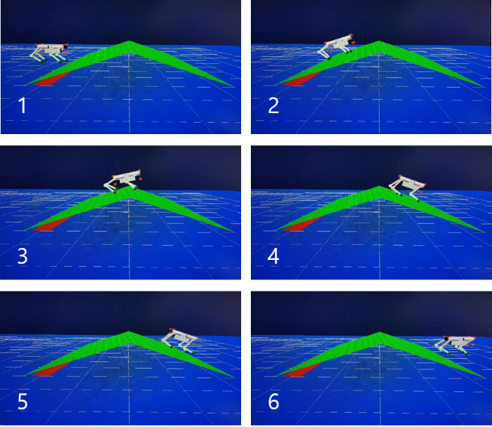

Figure 5. The quadruped robot walks across a sloped terrain (The time interval between the snapshots is 2 seconds)

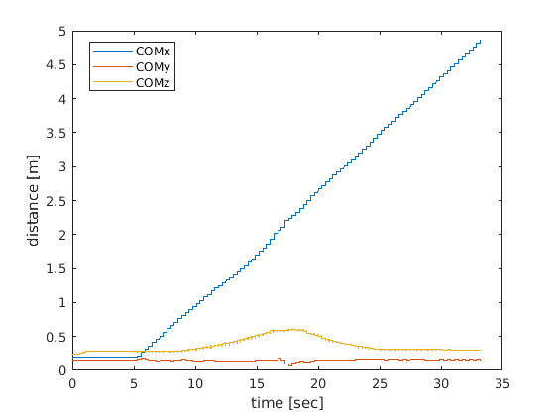

Figure 6. The CoM trajectories of the quadruped robot while walking across the sloped terrain.

Conclusion

The two-level optimization based control framework considers the reactive balance recovery strategy and full body inverse dynamics control problem separately, and it has potential to enable fast, dynamic, versatile interactions safely and robustly.

High-level controller: Contrary to general CP approach that only outputs a step location to maintain the stability of the robot, we add an drift compensation based CP approach with a simplified model that can hold steady position with noisy sensors.

Low-level controller: In contrast to the hierarchical method that formulates the cost functions as hard constraints, we use soft constraints by adding corresponding terms with weight in the cost function to handle the unfeasible solution and equal-priority motion problem. Furthermore, we use full optimization states (joint acceleration, joint torque, contact force) to formulate the convex optimization problem, since this choice of states is able to handle state dependent constraints such as non-slip friction constraints, joint torque limit, etc. Although the low-level controller is similar in spirit to [4]’s work, but the objective cost functions according to behavior motion are focused on quadrupedal robot rather than bipedal robot.

We verified and showed via videos that the proposed control framework can robustly stabilize the quadruped robot under large external disturbances, and compensate steady error to prevent the drift.

Reference

1. Khatib O (1987) A unified approach for motion and force control of robot manipulators: The operational space formulation. IEEE Journal of Robotics and Automation 3(1): 43–53.
2. Hutter, M., Sommer, H., Gehring, C., Hoepflinger, M., Bloesch, M., & Siegwart, R. (2014). Quadrupedal locomotion using hierarchical operational space control. The International Journal of Robotics Research, 33(8), 1047–1062.
3. Herzog, A., Righetti, L., Grimminger, F., Pastor, P., & Schaal, S. (2014). Balancing experiments on a torque-controlled humanoid with hierarchical inverse dynamics. In IEEE/RSJ International Conference on Intelligent Robots and Systems (IROS), Chicago.
4. Feng, S., Whitman, E., Xinjilefu, X., & Atkeson, C. G. (2015). Optimization‐based full body control for the DARPA Robotics Challenge. Journal of Field Robotics, 32(2), 293-312.
5. Sentis L (2007) Synthesis and control of whole-body behaviors in humanoid systems. PhD Thesis, Stanford University.
6. Aghili F (2005) A unified approach for inverse and direct dynamics of constrained multibody systems based on linear projection operator: Applications to control and simulation. IEEE Transactions on Robotics 21(5): 834–849.
7. Mistry M, Buchli J and Schaal S (2010) Inverse dynamics control of floating base systems using orthogonal decomposition. In: Proceedings of International conference on robotics and automation (ICRA), Anchorage, AK, 3–8 May 2010, pp. 3406–3412.
8. De Lasa, M., Mordatch, I., & Hertzmann, A. (2010). Featurebased locomotion controllers. ACM Transactions on Graphics, 29(4), 131:1–131:10.
9. Bouyarmane, K., Vaillant, J., Keith, F., & Kheddar, A. (2012). Exploring humanoid robots locomotion capabilities in virtual disaster response scenarios. In 12th IEEE-RAS International Conference on Humanoid Robots (Humanoids) (pp. 337–342), Osaka, Japan.
10. Vukobratović, M., & Borovac, B. (2004). Zero-moment point—thirty five years of its life. International journal of humanoid robotics, 1(01), 157-173.
11. S. Kajita, M. Morisawa, K. Miura, S. Nakaoka, K. Harada, K. Kaneko, F. Kanehiro, and K. Yokoi, “Biped walking stabilization based on linear inverted pendulum tracking,” in IEEE Int. Conf. on Robotics and Automation (ICRA), 2010, pp. 4489 –4496.
12. Pratt, J., Carff, J., Drakunov, S., & Goswami, A. (2006, December). Capture point: A step toward humanoid push recovery. In Humanoid Robots, 2006 6th IEEE-RAS International Conference on (pp. 200-207). IEEE.
13. Rebula, J., Canas, F., Pratt, J., & Goswami, A. (2007, November). Learning capture points for humanoid push recovery. In Humanoid Robots, 2007 7th IEEE-RAS International Conference on (pp. 65-72). IEEE.
14. Raibert, M. H. (1986). Legged robots that balance. MIT press.

1. S. Hong is with the Korea Advanced Institute of Science and Technology, Daejeon, 34141 Republic of Korea. (e-mail: seungwoohong@kaist.ac.kr). He leads the group, and performs the low-level controller, and advanced robot simulation with Choreonoid.

   J. Choe is with the Korea Advanced Institute of Science and Technology, Daejeon, 34141 Republic of Korea. (e-mail: ksks6281@kaist.ac.kr). He performs the high-level controller, and basic simulation with Matlab.